A194-Afr-Egy-Ushabti-New Kingdom-18th Dynasty-1570-1290 BCE

**Case No.: 2**

**Formal Label:**

**Display Description: Composite duplex wig, upperpart striated, lower part echeloned, hands not crossed, holding two hoes. Six registers of hieroglyphs, mostly illegible.**

**Accession Number: A194**

**LC Classification:** DT62

**Date or Time Horizon:** New Kingdom-19th Dynasty, 1291 – 1278 BCE

**Geographical Area: Luxor, Egypt-Valley of the Kings**

**Map, GPS Coordinates:** [25°44′23.3″N 32°36′06.8″E](https://tools.wmflabs.org/geohack/geohack.php?pagename=KV17&params=25_44_23.3_N_32_36_06.8_E_type:landmark_region:EG)

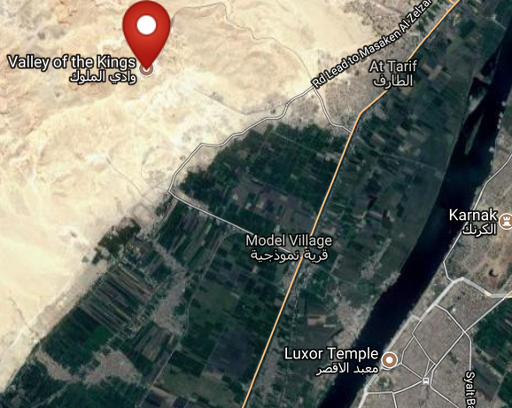 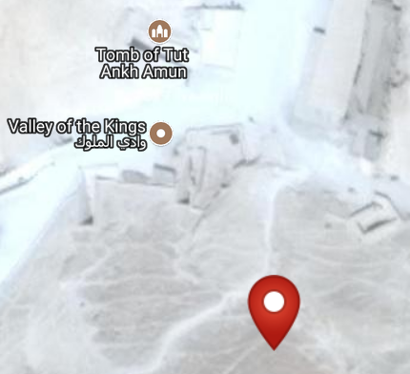

Figs. 3-4. Maps of Valley of the Kings from http://latitude.to/lat/25.73972/lng/32.60167

**Cultural Affiliation:** New Kingdom

**Medium:** blue faience

**Dimensions: H 170,41 mm; 6.709 in  
Weight:124 gm; 4.25 oz**

**Provenance: unknown**

**Condition: original**

**Discussion: This Ushabti represents an unusual headdress with the echeloned lower part,**

**References:**

`